Y2Q2W8

The Writing on the Wall

Ask: Have you ever got in trouble for something you didn't do?
Ask: Have you ever seen someone do something wrong but not get in trouble for it?

Revise: Nebuchadnezzars dream and it's meaning.

Bible Story

Ask: Did King Belshazzar respect God?
Ask: Why do you say that?
Ask: Was God watching Belshazzar?
Ask: Did you know that God is always watching you too? Can you see God? How do I know that He is watching? – Because the Bible says so.

Show: The binoculars.

Sing Song

Return to tables
Memory Verse: Fill in the blanks and then say the memory verse on the colouring page and finish.

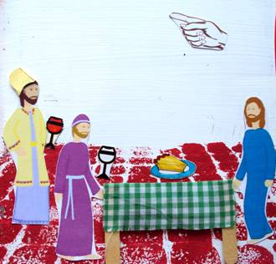
Say: This term we are going to make fridge magnets to tell the Bible stories with. You will keep your magnets in a special magnet book which we will loan to you until the end of the term and then you can take the magnets home – but we will keep the magnet books for next time. DO NOT DRAW OR WRITE ON THE MAGNET BOOKS

Magnet Books
- Colour in the cup and the plate of food with textas
- Put a magnet on the hand

Discuss the following depending on age, interest and time:
Revise how todays lesson starts fulfilling Nebuchadnezzars dream.
How do you feel when you see people doing bad things and not seeming to get in trouble for them?
Look for verses or stories in the Bible that tell us that God is watching us. 1 Samuel 16:7 – The Lord looks on the inside. Psalm 121 – God watches you. Luke 12:7 – Your hairs are numbered.
What would people think if they were watching you all the time?
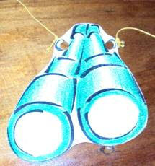
Revise all the different things that happened in Daniels life.

Craft 2: Binoculars
- Colour in the binoculars
- Use the magic UV pen to write "GOD SEES" on the lenses
- Punch holes and tie on a string

Say: When you look at these binoculars normally they look very ordinary, but when you hold them next to the black light you can see that "God Sees"

Say: When you are tempted to do something wrong – I hope you will remember these binoculars and remember that someone is watching you. And that you will make a good decision.

Finish with prayer.

